Abstract— This paper highlights the design of a chemistry based puzzle game. The design of the game is meant to teach basic concepts of chemistry related to covalent bonds. The area of Educational Technology is still not so developed for young learners. An interactive technology is required for learning effectively and efficiently. The result is Atoms to Molecule (A2M). In A2M the environment of the levels are designed as such a player will have complete feel of chemistry lab. This game tries to intact fun with education. In this paper we are trying to highlight the features of chemistry objects which are used in our game. While teaching the basic concept of Chemistry, like bonds between atoms and how molecules are formed teacher usually gives examples to define the formation of bonds. However, the concepts of atoms and molecules are difficult for students to imagine. This game A2M has clearly presented the concepts lying behind the formation of bonds, game rules and simple game levels is chosen as the teaching aid along with a fun puzzle game.
Learning Chemistry Through Puzzle Based Game: Atoms to Molecule
Maya Agarwal¹, Bengal Institute of Technology, WBUT, India
Shubhajit Saha², Bengal Engineering and Science University, Shibpur, India
¹maya.agarwal2@gmail.com, ²shubhajit.saha@students.becs.ac.in

Index Terms— Chemistry, Game Based Learning, Game Design, Puzzle.

INTRODUCTION
GAME designing is becoming very popular now a day. This is because now a day’s games are not made only for fun and entertainment but also for education [1]. Digital games (video games or computer games) are positively accepted among children and teenagers [2, 3]. Multimedia based learning environment are more efficient than reading contexts. It can easily grasp interest of students. However it is generally found Digital Games Based Learning (DGBL) cannot maintain the fun element up to that level. It is becoming very challenging to combine education with fun in equal ratios. Computer games with exciting interactive activities and interesting multimedia provide a way to motivate students to learn actively and interestingly. Normally the time period of classes are 45 – 50 minutes, so it is very important to design simple, short and interesting games. Education games, which take 20 hours to teach, can become boredom again. Some educational games are very complex. Educational technology still lacks in research on how to design game environment that foster knowledge construction and deepen understanding and problem solving while engaging and entertaining the player at the same time [4].
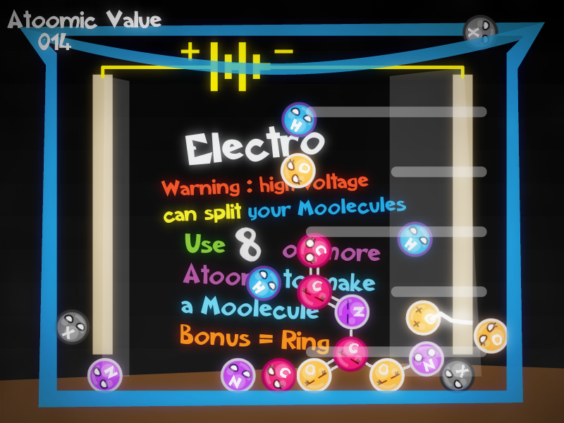
Fig. 1. Atoms to Molecule game.
Teachers usually need to explain the concepts of formulation of molecule from atom, which can be very difficult to demonstrate. It motivates this paper of applying the game-based learning approach to assist students in manipulating and observing the relationship of atoms to form molecules [5]. Research data also showed that the use of games in education is perceived as a useful tool for learning and helped to engage students in educational experiences towards achieving specific learning goals and outcomes [3, 6, 7, 12].
The game A2M is interesting and more acceptable for students to realize the abstract concepts through the fun and interactive world of the game. With our survey, some practitioners used the puzzle games as a teaching tool [8, 9, 10]. It seems that the game is interesting and more acceptable for students to realize the abstract concepts through the real world examples.
This paper is organized as follows. First we discuss the Game Description. Second, we discuss the details of the different objects used in the game. Third, we introduce the design of different levels used in the game and scoring patterns. Last, we report the qualitative and quantitative findings from a user study with three groups of students.

Game Description
Atoms to Molecule (A2M) is a single player puzzle game where player is in a Chemistry lab. Each level consists of lab equipments and atoms. The levels start with the atoms entering from the top of the screen. The number of atoms in a level is constant and the type of atoms is generated randomly. Player can drag and drop the atoms to make bonds with nearest atom [11]. A player can easily replace the atoms by joining them to form molecules, this molecule disappears and new randomly generated atoms replace the used atoms.
A player can make molecule by joining different atoms. The task of a player is to make molecules and solve different puzzles of Chemistry lab. Player can arrange atoms to make ring, linear, small or big molecules. The lab equipments in which A2M is played can be test tube, beaker, conical flask and other (see Fig. 1). The basic goal in each level is to make different kinds of molecules with different objectives. To make a complete molecule all the atoms in the molecule must be sleeping which can be achieved by using all their bonds (see Table 2).
TABLE II
Atom Eye State Chart
State | Look  (Girl) | Look  (Boy) | This happens when
Normal |  |  | The atom in the free state.
Open | 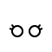 |  | The atom is bonded with some other atom but all its bonds are not satisfied. In this state the atom jitters.
Cross |  |  | It comes in contact with some enemy causing it to break all its bond. It changes back to normal. This is a short time effect.
Happy |  |  | All the bonds of the atom are satisfied. This is a momentary effect; it automatically changes to sleep after some times.
Sleep |  |  | All the bonds of the atoms are satisfied.
Boy atoms are Hydrogen, Nitrogen and ElementX.
Girl atoms are Oxygen and Carbon
A2M is a puzzle based game base on the covalent nature of atoms. Here the atoms are used as a puzzle piece and to form a molecule is to solve a puzzle. While solving these puzzle students learns to make molecule from atoms using covalent bonds, which can be single, double and triple.

Basic Game Objects

Atoms
The main character of the game is atom. The look of the atom is developed to be more attractive to the young learners. The symbol in the head and the circular body color suggest the type of element (see Table 1). The four elements with different number of bonds used in this game are Hydrogen, Oxygen, Nitrogen and Carbon. ElementX is an element, which can make variable bonds with maximum of three, designed to add fun in the game.

Fig. 2. Details of Carbon Atom
Symbol

Eye
We have assigned the gender depending upon the total number of bonds an atom can make. The intension behind assigning the gender is to distinguish between odd and even number of bonds (see Table 2). For odd number of bonds in atom we have assigned boy e.g. Hydrogen. For even number of bonds in atom we have assigned girl e.g. Oxygen.
TABLE I
Atom Detail Chart
Element | Symbol | Color | Total Number of bonds
Hydrogen | H | Blue | One
Oxygen | O | Orange | Two
Nitrogen | N | Violet | Three
Carbon | C | Red | Four
ElementX | X | Black | Variable with maximum of Three

This assignment of gender leaves deep impact on children mind to easily figure out between odd and even number of bonds an atom can make. Thus this assignment serves both the purpose of education and entertainment.
The different eye states are connected with different state an atom can have (see Table 2).

Bond
When an atom dragged and dropped near an atom a bond forms between them. Bonds can be Single, Double or Triple. The atom always tries to make the highest number of bonds. When an atom is dragged it shows the bonds left to be formed and when it is brought near another atom it show the possible number of bonds that can be formed (see Fig. 3).

Fig. 3. Different kind of bonds.
Free bonds

Possible
bonds

Old bonds

Bond Angle
Bond angle define the angle in which the newly attached atom will arrange itself. The angles in which an atom can be attached are 0, 120, 240, 60, 180 and 300 degree. The angles are chosen so that no two atoms are very close to each other.

Game Enemy

Radioactive Atom
TABLE III
Atom Detail Chart
Level | Description | Learning Objective
Tutorial | This is an introductory level here the different atoms used (see Table 1) in the game are introduced. The molecule a player has to make is shown as a hint in the background of the level. | The player learns the game controls and tries to make some basic molecules.
Ring-O-Ring | In this level a player have to make 8 ring molecules to move to the next level. | The player learns to make ring molecules.
Absolute Zero | This is a fast-paced level the bonus in the level is ring bonus. In the level a Kelvin scale thermometer showing the temperature is constantly increasing. A player must make molecule to drop the temperature to Zero Kelvin. The molecule with rings gets a bonus and the temperature decreases quickly. | The player learns to make bigger ringed molecules within specific time.
Clear All | In this level a player has to make a single molecule using all the 10 atoms present in the level for five times. | The player learns the trick of using all the bonds to form a single molecule.
Electro | The level contains an electrode which decreases the level area. The objective of the level is to make molecule having 6 or more atoms, which increases up to 16 at the rate of two atoms at a time. (see Fig. 1) | The player learns to make bigger molecules efficiently using less area in the screen.
pH Scale | This is a fast-paced level too; the bonus in the level is Hydrogen Bonus. A pH meter showing a constant increase, a player must make molecule containing more hydrogen to drop the level in the pH meter. | The player learns to make a molecule utilizing maximum number of hydrogen.
Clipboard | In this level is player must make the simple molecular formula given in the bottom of the screen. | The player learns to make molecule of a given molecular formula.
Radio Active | This level contains four radioactive atoms. The objective is to make molecule having 2 or more atoms, which keeps increasing two at a time up to 10. | The player learns to tackle game enemy while making molecules.

This used as an enemy in the game. It has a radioactive sign on its head and the expression of the eyes shows anger. In the game it emits green smoke (see Fig. 4). It moves randomly in the level area and breaks all the bonds of the atom that comes in contact. To make it inactive we can drag and drop it an empty space of the level area, but the moment it come in contact with other object it becomes active again. As radioactive substances are very harmful for our environment, similarly we tried to demonstrate that radioactive substances are enemy to our molecular structure in the game.

Fig. 4. Radioactive Atom in action

Electrode
They are static enemies, they can’t move around like the radioactive atom. When the atoms come in contact with the electrode it gets a heavy shock and its bonds get split (see Fig. 1).

Game Modes

Adventure
Adventure Mode is the primary mode, and it allows a player to learn the ways to make molecules and then advancing to the expert levels. Adventure Mode is divided into 8 stages. The stages and how it is related to learning objective are as shown on Table 3.

Lab Setup
Lab Setup is a sand box mode where a player can setup a lab (see Fig. 7). Lab Setup is divided into:

Equipment mode:
In this mode player can add, move, rotate and clamp lab equipments in the lab area. The equipments are under physics simulation in this mode, but the atoms are not simulated and are kept transparent, i.e. no collision takes place with the atoms.
Lab Equipments that are provided are electrodes, thermometer, pH scale, funnel, test tube, conical flask, measuring cylinder, beaker and clipboard.

Atomic Mode:
In this mode a player can add or remove atoms in the Lab area. Molecules can be formed using the added atoms. The types of atoms added are generated randomly. But the molecules formed will not be removed automatically in this mode as it happens in case of Adventure mode. In this mode atoms are under physics simulation but equipments are static.

SCORING
The scoring pattern is chosen to suit the chemistry environment. When a molecule is formed and it meets the level objective “Atomic Value” (AV) is awarded in the form of scores (see Fig. 5). Sometimes AV is associated with a bonus multiplier, which gets multiplied with the AV and the total is awarded. The total AV obtained in the level is summation of all the AV of the molecules; it is displayed in the top left corner of the game screen in the levels of the Adventure mode (see Fig. 1).

Atomic Value
Atomic Value (AV) of a molecule is the sum total of all atom’s AV present in it. AV of an atom is the number of atoms it is bonded to. So more atoms it is attach to, more is the AV and more is the score. For Example: A carbon attached to an oxygen and two hydrogen atoms, Molecular formula CH₂O, AV of the molecule = 3 (for carbon) + 1 (oxygen) + 1 (hydrogen) + 1 (another hydrogen) = 6.

Ring Bonus
In most of the levels if a player can form ring molecule the AV gets multiplied with a factor. The factor depends upon the number of rings in the molecule. For Example: If a molecule have 2 rings AV will be multiplied with (2 + 1) = 3 times.

Hydrogen Bonus
With Hydrogen bonus the AV is multiplied with the total number of Hydrogen present in it. So a player needs to attach more hydrogen to a molecule to get more bonuses.

Technology
We uses Microsoft XNA [13] cross-platform game engine, using C# and object-oriented technology to develop A2M. For the Physics simulation we used Box2D.XNA [14] a C# port for Box2D.
The collision detection of Box2D.XNA becomes very poor when any molecule, a complex structure of bodies connected by joints, comes in contact with other dynamic body, equipments. The poor collision was forcing the atoms to tunnel through the moveable equipments, dynamic body, but it was not affecting the non-moveable table top, static body [14]. So in Lab Setup two different mode like Atomic and Equipment modes were created to solve the collision problem. In the Equipment mode equipments are dynamic which allows it to move and the atoms are kept transparent to avoid collision between atoms and equipments, where as in the Atomic mode equipments are kept static and the atoms and molecule collide with the equipments.

User Study

Goals
A user study with 15 student of different age group was made, to understand the play experience and improve the game design [15]. The research questions were designed to gather the feedback to improve A2M and see how the design was helpful in learning the basic concepts of chemistry. It also determined how the characterization of the chemistry elements helped to grab the attention of the young learners. Our main goal is to realize how learning games can grasp the interest of the player and how much knowledge they gain after playing the game. We hoped to understand the patters of learning among children through games.

Fig. 5. A molecule disappearing showing up Molecular formula, Atomic Value and a bonus multipler.
Molecular formula

Atomic Value

Bonus

Participants
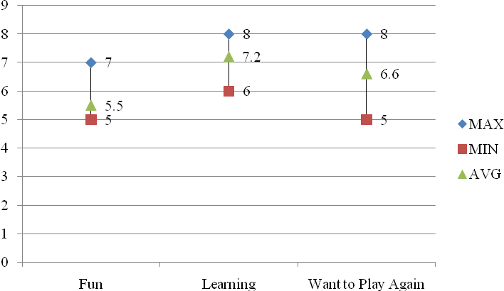

Fig. 6. Feedback Scores.
We selected fifteen participants varying from age group of 10-20. We categorize them according to their age Group 1 (10-13 years), who are still not introduced to very basic concepts of chemistry, Group 2 (14-16 years) who have started with learning chemistry, Group 3 (17-20 years) who want to explore new things out of this subject. Few of them have never played any educational game before. Four of them were girl. Three of them were very poor in bonding concepts of Chemistry. Five were very curious about game play.

Procedure and Setting
The user study included three parts, first the player learned the game interface, and we demonstrate a small demo instructional video of the game [16]. A researcher gave an introduction to the game controls by following demo instructional video of the game play. Second the participants were instructed to stand in queue in the increasing age group. 4 students belong to each category. Students were introduced to the first level of the game i.e. tutorial level and were allowed to play other levels of the game. Third, the participants were asked few question related to learning through games and game play. The user study was conducted in an exhibition where we presented our game to school students.

Measures

Observation
A researcher took observation notes during game play, to record interesting movements of play and to generate related questions for the interview. The observation included how the player interacts and the reaction of the player on their first interaction with the game play.

Questionnaire
The questionnaire was divided into three sections: feedback about the game play, Chemistry concepts learned after playing A2M and about interesting aspects of the game. We used cross-checking questions to address the problem of misreporting.

Interview
At the end of the user study, we conducted a semi-structured interview. The interview focused on understanding the subjective experience of the players, including the strategies they adopted, things they learned, what made them adhere to the game, and the comparison between this game and other educational games they had played before.

Findings and Discussion

Feedback About The Game
We interviewed the students about what they like and dislike. We got positive feedback about the graphics which included characterization of atom, bonding system and the different lab equipments which build up the whole atmosphere of the game. They were comfortable with the controls of the game play which simply uses mouse to drag and drop. They found it very simple and effective way of learning covalent bonding. The negative feedback which we got about the game was that the types of atoms used were limited, only concepts of covalent bonds were shown.

Chemistry Concepts Learned
The feedback about the Chemistry concepts they learned while playing the game varied according to the age group. Students belonging to first group find it more entertaining rather than educational (2.3/5). The second group students find it quite educational (3.5/5), they find A2M an interesting way to learn covalent bonding (4.1/5). The third group students find the lab setup (see Fig. 7) very useful (3.8/5). They like the synchronization of chemistry concepts with different levels of the game (4.6/5).

Interesting Aspects
This user study had some initial findings on the interesting aspects of the game. In the questionnaire, the students found the game enemies to be well designed (4.4/5); they liked the breaking of bonds with the help of electric shock in Electrodes (3.8/5). They find the lab setup to be really interactive and well designed (4/5). They liked the eye state of atoms to define their states (4.8/5). They preferred more levels in the game (2.4/5). They felt the difficulty of the level moderate (3.2/5).
We also observed that when the students Drag and Drop to join the atoms of Hydrogen for the first time to make a molecule of Hydrogen, they get the feel how molecules are formed and they started to create all kinds of molecules which they have came across in their text book. After making the first molecule of Hydrogen most of the student wanted to create Water (H₂0) molecule as it is a very basic molecule. As they familiar with the game play they were exited to move to the next level before completing one.
The user study of A2M showed that it can be used as educational tool which helped us in learning through games.

Conclusion And Future Work
We have discussed the basic design of A2M and how it is related with the basic concepts of covalent bonding. We have already discussed about the design of atom, and other details like what elements are used, how many bonds an element can form, and their eye expressions (see Fig. 3). We have tried to explain type of bonds it can form. Details of different levels are discussed. Though A2M is educational game but to add fun we have used enemies which are related to other concepts of chemistry.
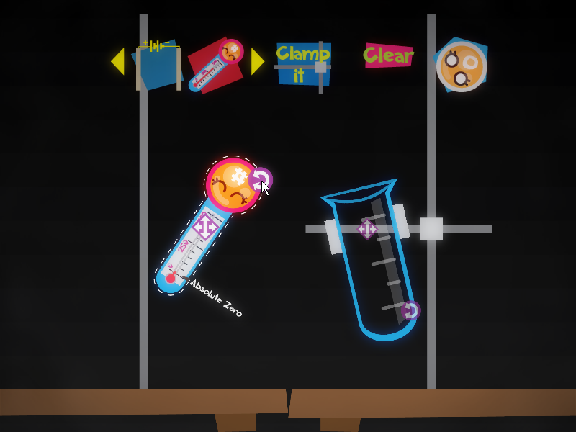
Fig. 7. The game in Lab Setup mode.
The score is given in the form of Atomic Value and other bonus is added in the game. Our main contribution is to demonstrate a practical approach of covalent bonding. In the meantime, we hope to explore more interesting concepts of Chemistry which can be added to our game.

References
- Edu-Games, http://en.wikipedia.org/wiki/Edu-Games.
- Rubijesmin Abdul Latif. Understanding Malaysian students as gamers: experience. Proceedings of the 2nd International conference on Digital interactive media in entertainment and arts, 2007, pp. 137-141.
- Mireilla, B. Assessing the educational potential of video games, October, 2005, pp. 1-18.
- Kiili, K. Evaluations of an experiential gaming model. An Interdisciplinary Journal on Humans in ICT Environments, Vol. 2(2), October, 2006, pp. 187-201.
- Li Caii, Fangyu Liul, Zhihong Liangi. The Research and Application of Education Game Design Model in Teaching Chinese as a Foreign Language.
- Vasiliou, A. & Economides, A.A. Game-based learning using MANETs. Proceedings of the 4th WSEAS/IASME International Conference on Engineering Education, Agios Nikolaos, Crete Island, Greece, July 24-26, 2007.
- Garcia-Barcena, J. & Garcia-Crespo, A. Game based learning: a research on learning content management systems. Proceedings of the 5th WSEAS International Conference on Educational Technology, Tenerife, Canary Islands, Spain, December 16-18, 2006.
- Binary Color Device from Cut-the-Knot, http://www.cut-theknot.org/pythagoras/bicolor.shtml, Mar. 2010.
- Logic Puzzle from Puzzler Paradise, http://www.puzzlersparadise.com/page1034.html, Mar. 2010.
- Wolf Sheep & Cabbage from Plastelina Interactive Logic Games, http://www.plastelina.net/game1.html, Mar. 2010.
- 2D Boy, World of Goo, http://www.worldofgoo.com/, 13 October, 2008.
- Nor Azan Mat Zin 1, Wong Seng Yue. History Educational Games Design, 2009 International Conference on Electrical Engineering and Informatics 5-7 August 2009, Selangor, Malaysia.
- Microsoft, App Hub, http://create.msdn.com/, March 4, 2004.
- Erin Catto, Box2D Manual, http://www.box2d.org/manual.html, 2006.
- Barbara M. Wildemuth, Why Conduct User Studies? The Role of Empirical Evidence in Improving the Practice of Librarianship. Proceedings of INFORUM 2003: 9th Conference on Professional Information Resources, Prague, May 27-29, 2003.
- Duy-Nguyen Ta Huynh, Karthik Raveendrany, Yan Xuz, Kimberly Spreenx, Blair MacIntyre. Art of Defense: A Collaborative Handheld Augmented Reality Board Game.Proceedings of Sandbox 2009: ACM SIGGRAPH Video Game.

 

